Study of ionomer adsortion on monocrystalline surfaces and its effects on reactions related to fuel cells

Victoria Gámez ^{a,*} Rosa M. Arán-Ais ª Víctor Climent ª

ª Instituto de Electroquímica, Universidad de Alicante, Ap. 99, E-03080 Alicante, España
*vggg4@alu.ua.es
Abstract

Proton-exchange membrane fuel cells (PEMFC) are electric energy producing devices, most typically fed with O₂ and H₂. The key element of the PEMFC is a polymer electrolyte membrane, which conduces protons from the anode to the cathode. Both electrodes are composed of an active layer, usually of Pt or related alloys, in direct contact with the membrane. A particular type of PEMFC uses Nafion® membranes (a polymer based on perfluorsulphonic acid, PFSA). Nafion consists of a hydrophobic polytetrafluoroethylene (PTFE) backbone, bonded to perfluorovinyl ether groups, terminated with a hydrophilic sulfonate group (-SO₃H). Previous studies on electrocatalysis have proven that processes occurring in the metal | electrolyte interface have an important effect on reaction rate and selectivity. Hence, studying the Metal-ionomer | electrolyte interface is essential to improve the performance of catalysts, for a variety of reactions such as oxygen reduction, hydrogen evolution and organic molecule electrooxidation, such as formic acid and methanol.

The strategy for getting an accurate description of the processes occurring on the metal-ionomer | electrolyte interface is covering the metal with either a layer of ionomers with the same structure as the membrane or a layer of ionomers with lower molecular weight, but having the same functional group as the membrane.

Earlier studies on Nafion ionomers demonstrated that the voltametric response of the Pt-SO₃ | HClO₄ interface depends on the preparation conditions (e.g. concentration, temperature and drying atmosphere). The first step in this work will be the standardization of those conditions, to achieve a reproducible voltametric response. Figure 1 shows some initial voltametric results of different Nafion 117 coverings on a Pt(111) electrode. A second step will be the study of the adlayer topography using Atomic Force Microscopy and its characterization using Fourier-transform Infrared Spectroscopy. This study can be continued, varying electrolyte, e.g. metasulphonic acid (CH₃-SO₃H) or NaOH and pH; varying the electrode composition (e.g. Pt/Pd, Pt/Ru, Ni); or including adatoms (e.g. Fe, Co, Ni or Bi, As, Ge). For each metal-ionomer | electrolyte, important interfacial properties will be determined, such as the anion adsorption coverage or the potential of zero charge, through probe molecules or laser-induced temperature jump technique. The study can be further extended to different ionomers, varying the backbone length and the number of ether perflourvinyl groups of the membrane.
A
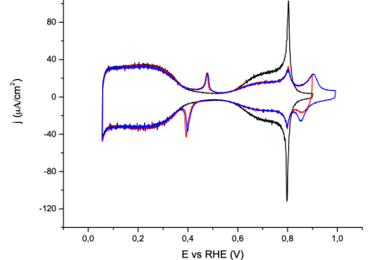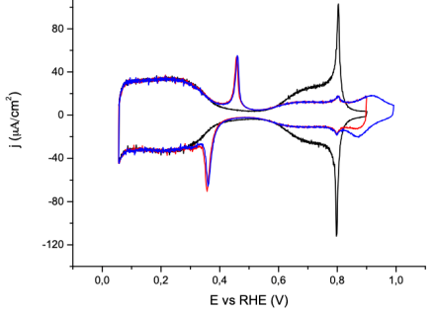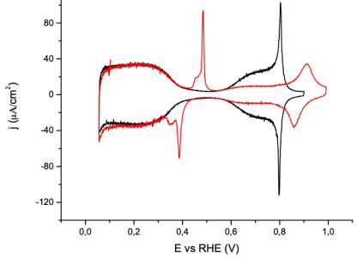
C
A
B
Figura 1. Cyclic voltammetry of Pt(111) | HClO₄ 0.1M. Blank: black line, A), B) and C) Different Nafion coverages. Higher Nafion concentration implies greater peak of SO₃ anion adsorption at 0.48V, therefore the adsorption of OH starting at 0.55V decreases. The H adsorption region from 0.06 to 0.34V remains invariant.

