Studies of the surface structure for the electrochemical valorization of biomass

Lorena Chico-Mesa*
Mentor: Enrique Herrero Rodríguez
Director: Enrique Herrero Rodríguez and Rosa María Arán Ais

Institute of Electrochemistry, University of Alicante, Alicante, Spain
*lorena.chico@ua.es

Abstract

5-Hydroxymethylfurfural (HMF) and furfural (FF) are molecules derived from lignocellulosic biomass that belong to the furan group. These molecules have received considerable interest because through their oxidation and reduction, products of substantial added value can be obtained. For example, 2,5-furandicarboxylic acid (FDCA), which could replace terephthalic acid, a precursor of PET plastic, is obtained from HMF [1]. On the other hand, one product of FF oxidation is furoic acid, an intermediate in the pharmaceutical industry that can be used as a precursor to FDCA [2]. The selective oxidation and reduction of these molecules need to be studied not only for their potential industrial importance but also as models for the catalytic processing of furans and organic molecules that share common characteristics. In this regard, the use of single-crystal electrodes is crucial for investigating the fundamental aspects underlying these processes.
Considering the above, during the development of this thesis, single-crystal Au electrodes will be used to study the electrooxidation of HMF and FF. On the other hand, the electroreduction will be studied using single-crystal Cu electrodes. By studying these reactions on single-crystal electrodes, we aim to gain fundamental information on the effect of surface structure, as well as insights into the processes taking place at the solid-liquid interface. Furthermore, the products obtained will be determined using HPLC to study the correlation between the electrode surface and the selectivity of the reaction. In addition, IR spectroscopy will be used to gather information about possible reaction intermediates. The ultimate goal would be to synthesize Au and Cu-shaped nanoparticles to transfer these fundamental studies to practical systems.
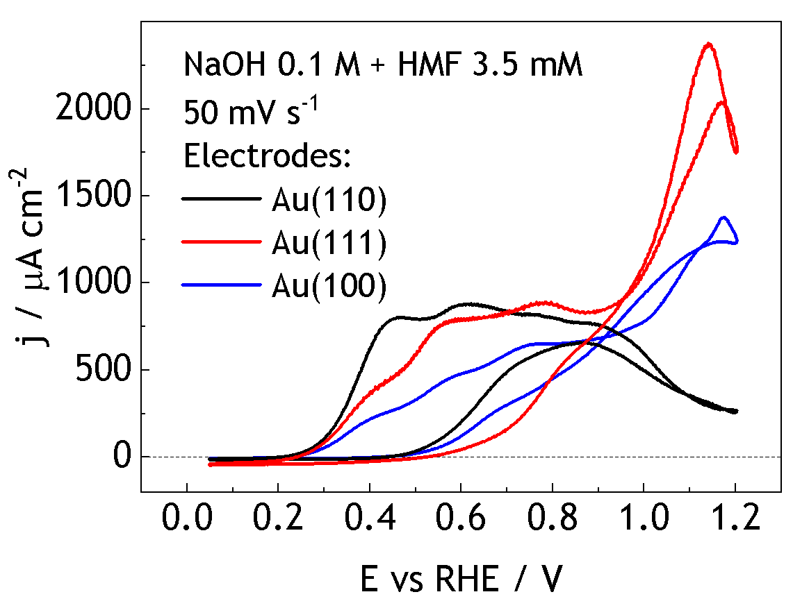
Figure 1. Cyclic voltammograms of the HMF oxidation on Au electrodes.
References
[1] van Putten, R.-J., van der Waal, J. C., de Jong, E., Rasrendra, C. B., Heeres, H. J., de Vries, J. G. 2013. Hydroxymethylfurfural, A Versatile Platform Chemical Made from Renewable Resources. Chem. Rev. 113, 1499−1597.
[2] A. Banerjee, G. R. Dick, T. Yoshino and M. W. Kanan. 2016. Carbon dioxide utilization via carbonate-promoted C–H carboxylation. Nature. 531, 215-219.

