Development of lactate electrochemical biosensors in sweat for wearable applications

Valeria Colmenaª, Jaime Punter ^{c}, Sara Santiago^{b}, Javier Aguilar ^{c}, Genis Rabost ^{c}, Samantha Toinga ^{c}, Albert Alvarez ^{c}, Andrea Fajardo ^{c}, Andrea Cardona ^{c}, Xavier Muñoz ^{c}, Xavier Muñoz-Berbel^{b}, Gonzalo Guirado^{a,*}

ªDepartamento de Química, Universidad Autónoma de Barcelona, 08193, Bellaterra (Barcelona), Spain
^{b} Instituto de Microelectrónica de Barcelona (IMB-CNM, CSIC), Bellaterra, Barcelona 08193, Spain
^{c} Onalabs Inno-hub, S.L., Avinguda Parc Tecnològic 3, 08290, Cerdanyola del Vallès (Barcelona), Spain

*Email: v.colmena@onalabs.com; gonzalo.guirado@uab.cat

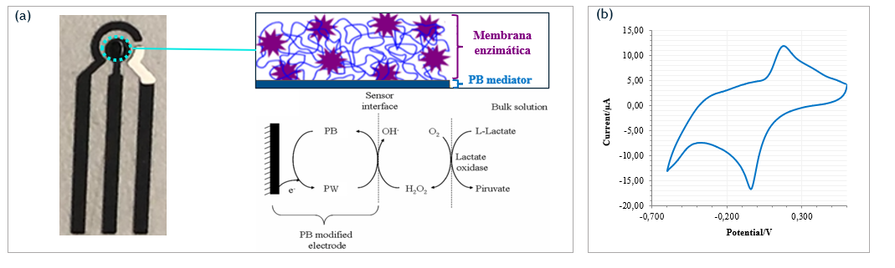
In recent years, sweat has emerged as a non-invasive alternative for the detection of biomarkers due to its easy accessibility. In addition to water (99%), sweat contains electrolytes, metabolites (glucose, lactate, ethanol...), and small amounts of sugars, proteins, and metallic ions [1]. Lactate measurement in sweat is the most promising approach, as it is generated during physical exercise due to oxygen deprivation and directly affects muscle performance [2]. Therefore, monitoring lactate levels will enable sports personnel to create more precise training protocols. This works shows the design, fabrication, and implementation of an electrochemical sensor for lactate measurement in sweat (Figure 1). In a first stage, the sensor electrodes are designed, and different techniques for implementing the Prussian blue mediator layer are studied. Finally, in the second stage, the functionalization of the working electrode of the sensor with a specific enzymatic membrane is carried out to analyze the lactate present in the sweat samples.
Figure 1. (a) Schematic diagram of the operation of the developed lactate sensor. (b) Cyclic voltammetry of the sensor in sweat samples.
Acknowledgments
This work was supported by grants PID2019-106171RB-I00 and 2021 SGR 00052 (Generalitat de Catalunya). V.C. thanks the Generalitat de Catalunya (AGAUR) for his predoctoral “Doctorat Industrial” fellowship (2022 DI 032).
References
[1] Xu J, Fang Y, Chen J. Wearable Biosensors for Non-Invasive Sweat Diagnostics. Biosensors (Basel). 2021 Jul 23;11(8):245. doi: 10.3390/bios11080245. PMID:34436047; PMCID: PMC8391966.
[2] G. Kemp, «Lactate accumulation, proton buffering, and pH change in ischemically exercising muscle», Am. J. Physiol.-Regul. Integr. Comp. Physiol., vol. 289, n.o 3, pp. R895-R901, sep. 2005, doi: 10.1152/ajpregu.00641.2004.

