Fundamental studies and electrocatalysis on monocrystalline bimetallic surfaces of PtPd.

Gabriel Melle Baptista
Instituto de Electroquímica, Universidad de Alicante. Apdo. 99, 03080, Alicante, Spain
*gm111@alu.ua.es
Mentor: Enrique Herrero, Universidad de Alicante
Director: Enrique Herrero and Rosa M. Arán-Ais, Universidad de Alicante

Abstract
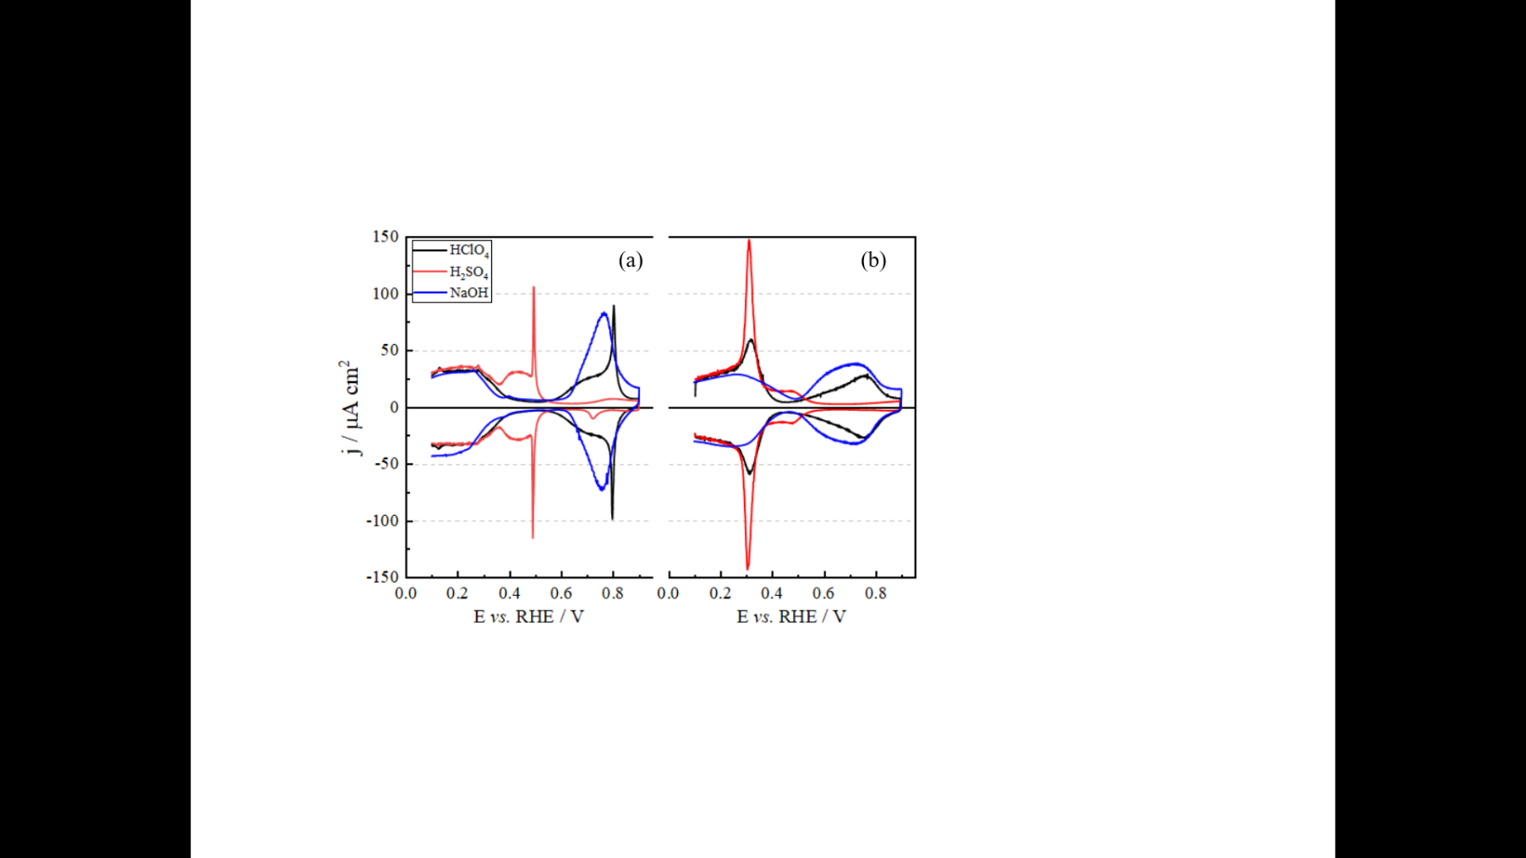
Platinum and palladium-based electrodes stand out for presenting excellent catalytic activity for different reactions with potential use in energy generation [1]. The deep knowledge about the interaction of the catalyst with the reaction medium is a key point in the design of electrodes with greater catalytic activity. In this context, the proposed research project seeks to elucidate the electrochemical and electrocatalytic behaviour of PtPd bimetallic electrodes with a well-defined surface. Initially the electrodes will be characterized by physical techniques, such energy electron diffraction (LEED) and X-ray photoelectron spectroscopy (XPS), and electrochemistry, such cyclic voltammetry (CV) [2]. These first analyses will allow establishing a relationship between the electrochemical behaviour and composition/orientation of the electrode surface. Fig. 1 shows a comparison between the voltammetric behaviour of (a) Pt(111) and (b) Pt-Pd(111) electrodes in different supporting electrolytes, showing the significant change in the interaction of the electrode with the species in solution, such as the adsorption region of ions and (hydro)oxygenated species[3]. The catalytic evaluation of the electrodes towards the formic acid oxidation reaction will be studied by voltammetry coupled with FTIR, DEMS and HPLC, allowing monitoring the formation of reaction intermediates of different nature (adsorbed, gaseous, or soluble). Finally, the experimental results will be translated into a reactional and kinetic mechanism that will be tested by numerical simulation, thus allowing to obtain kinetic parameters of the study reaction.
Fig 1. Voltammetric profile of (a) Pt(111), and (b) Pt-Pd alloy (111) with 20% Pd, in 0.1 M (black) HClO₄, (red) H₂SO₄ or (blue) NaOH.

References
[1] Parsons, R.; Vandernoot, T. J. Electroanal. Chem. 1988, 257, 9–45.
[2] Alvaréz, B.; Climent, V; Feliu, J. M. Electroanal. Chem. 2001, 497, 125–138.
[3] Watson, D.J; Attard G. A. Surface Science. 2002, 515, 87-93.

