Electrochemical oxidation of compounds derived from biomass for the sustainable production of chemicals and hydrogen.

Karol Viviana Mejia Centeno
Universidad de Barcelona
karol.mejiiacenteno@hotmail.com

Mentor: Elvira Gómez. Universitat de Barcelona, Martí i Franquès 1, Barcelona, Spain.
Director: Paulina R. Martínez-Alanis and Andreu Cabot. Catalonia Institute for Energy Research (IREC), Sant Adrià de Besòs, 08930 Barcelona, Spain;

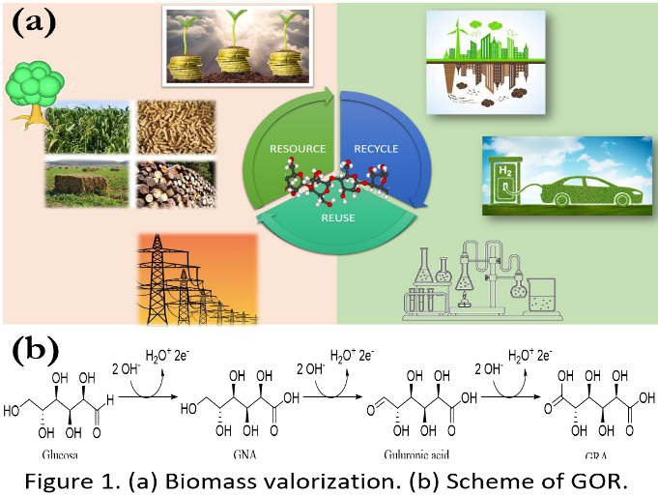
Abstract. The increase in greenhouse gases (GHG) in the atmosphere caused by using fossil fuels for human and economic activities has made a global warming emergency. Generating energy and chemical products in an environmentally friendly, sustainable, and economical way is a necessity. An alternative is the use of biomass-derived residues to produce highly valuable chemical compounds, and fuels (Fig. 1(a)). One attractive method for the conversion of biomass derivatives is electrochemical oxidation, which works at standard conditions of pressure and temperature. Cellulose the polymer composed of glucose subunits is one of the main biomasses residues and corresponds to 40 to 60% of its total residues, depending on its origin. Therefore, developing an efficient and economical glucose conversion method is by far-reaching importance for the sustainable development of the energy and chemical industries. GOR is relevant, not only for the cellulose abundance residues but also for the application of their oxidation products in the pharmaceutical industry. The main oxidation products for the glucose oxidation reaction (GOR) are gluconic acid (GNA), guluronic acid, and glucaric acid (GRA) (Fig. 1(b)). In the last 5 years, some remarkable materials for glucose oxidation have been reported, such as the reported by Zheng et al. (Fe _{0.1}-CoSe₂/CC, 1.12 V RHE, GNA, FE 99%) [1] or by Liu et al. (NiFeOx-NF, 1.39 V RHE, GRA, FE 83%). [2] However, in most of the reported works, the stability of the electrodes and selectivity is not discussed. This doctoral project focuses on the study of glucose oxidation coupled to hydrogen production. This project aims to synthesize and characterize electrodes with transition metals alloy nanomaterials which are abundant and have low toxicity by using it as catalysts over Ni foam/CC supports. A GOR mechanism will be proposed, in accordance with the results obtained.

Acknowledgments K. V. M. C, thanks for the scholarship from Call 906 of 2021 for Doctorates Abroad before the Ministry of Science, Technology, and Innovation of Colombia. The project leading to these results has received funding from the European Union’s Horizon 2020 research and innovation programme under Marie Skłodowska-Curie grant agreement No.801342 (Tecniospring INDUSTRY) and the Government of Catalonia’s Agency for Business Competitiveness (ACCIÓ).
References. [1] Zheng, D., et al., 2020. Three-birds-with-one-stone electrolysis for energy-efficiency production of gluconate and hydrogen. Applied Catalysis B: Environmental 277, 119178. [2] Wu-Jun Liu., et al. 2020. Efficient electrochemical production of glucaric acid and H₂ via glucose electrolysis. Nature Communications 11, 265.

