Investigación de procesos corrosivos y acumulación de residuos sobre superficies metálicas y elaboración de diseños higiénicos preventivos para las operaciones de limpieza y desinfección.

Celia López
Christeyns España. C/. Margarita Salas Falgueras, 2. 46729 Ador (Valencia)
*celotor@alumni.uv.es y celia.lopez@Christeyns.com

Mentor: José.J. García-Jareño. Laboratorio de Electroquímica. Universidad de Valencia. C/. Dr. Moliner,50. 46100 Burjassot (Valencia).
Director: Francisco Vicente Pedrós Laboratorio de Electroquímica. Universidad de Valencia. C/. Dr. Moliner,50. 46100 Burjassot (Valencia) y Fernando Lorenzo. Christeyns España. C/. Margarita Salas Falgueras, 2. 46729 Ador (Valencia).

Abstract
Cleaning and disinfection operations carried out in the food industry generate transformation processes of surfaces in contact with food. Detergents, disinfectants, food, and water that come into contact with metal surfaces are influential variables in their deterioration and contribute to a greater accumulation of dirt and can generate reservoirs of microorganisms and/or the formation of biofilms. The main objective of this research project is to evaluate the effect of detergents on the corrosion process of metals such as 316 stainless steel, aluminium, and brass in order to develop new, more effective detergents. This will require the development of an electrochemical technique to characterise and quantify the chemical nature of the residues deposited on the surfaces (food or biofilms), as well as to evaluate the process of corrosion of surfaces by food and detergents and/or micro-organisms.

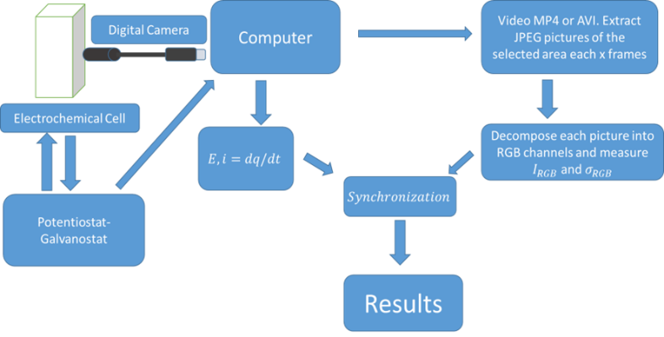
Figure 1. Procedure for obtaining quantitative kinetic information on metallic materials treated with detersive solutions.

References
[[1]Agrisuelas, J., García-Jareño, J. J. & Vicente, F., 2018. Quantification of electrochromic kinetics by analysis of RGB digital video images. Electrochem. commun. 93, 86–90.

