Electrochemical Conversion of Benzaldehyde and its Device Optimization
Li Gong
¹Universitat de Barcelona / ²IREC
lgong0928@gmail.com

Mentor: Elvira Gómez. Universitat de Barcelona, Martí i Franquès 1, Barcelona, Spain.
Director: Paulina R. Martínez-Alanis and Andreu Cabot. Catalonia Institute for Energy Research (IREC), Sant Adrià de Besòs, 08930 Barcelona, Spain.
Abstract
The development of cost-effective strategies to valorize biomass-derived products has a huge potential economic, social and environmental impact. Barriers exist of the current high cost of converting biomass into usable fuels and valuable chemicals. Within this project, I will design, engineer and characterize efficient electrocatalysts and to test the catalysts performance towards hydrogenation of biomass-derived chemical benzaldehyde into desired products benzyl alcohol or hydrobenzion and the oxidation of benzaldehyde into benzoic acid. From the litruature and our current results we think that the Pd is the suitable element for the benzyl alcohol product owing its intrinsic high performance towards hydrogenation and the oxygen-riched surface modificiation will also have a signifcient influence for the electrocatalyst performance. Witnin next few years I will considering prepare the semiconductor materials towards the hydrogenation of benzaldehyde to obtain another product hydrobenzoin and also considering develop prototype electrochemical systems where two coupled valorization reactions (an oxidation and a reduction) take place simultaneously. Furthermore, the optimization of the batch reactor(i.e. to shorten the electrodes distence) will be also included.
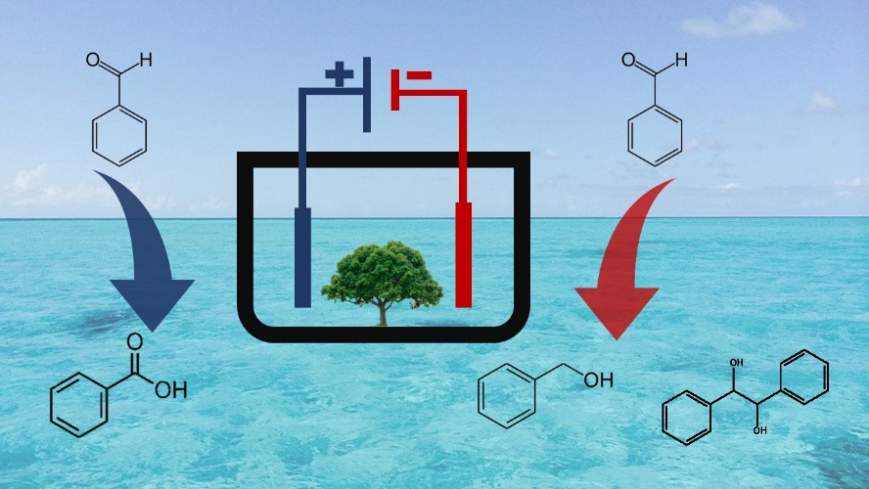
Figura 1. Electrochemical Conversion pathways of Benzaldehyde

