High performance catalyst decorated N,P-doped carbon nanosheet with multiple adsorption sites for stable lithium–sulfur batteries
Li Canhuang
Catalonia Institute for Energy Research – IREC Sant Adrià de Besòs, Barcelona 08930, Spain
canhuangli2020@gmail.com
Mentor: Elvira Gómez, Universitat de Barcelona.
Director: Prof. Andreu Cabot Catalonia Institute for Energy Research – IREC
Abstract.
Lithium-sulfur batteries (LSBs) are considered as the most promising candidate to replace lithium-ion batteries (LIBs) in next-generation energy storage systems. Compared with LIBs, LSBs are characterized by a sixfold higher theoretical energy density of 2600 W h kg⁻¹, and a potentially lower cost and environmental impact if the cathode material is chosen correctly. Despite these attractive advantages, the electrically insulating character of sulfur and the shuttle effect of intermediate lithium polysulfides (LiPS) greatly limit the practical application of LSBs. In addition, the serious volume changes and slow redox kinetics during the charge-discharge process also reduce the cycling life and power density.
In this project, I will design a porous carbon substrate with nitrogen and phosphorus to accommodate the volume expansion and high loading of sulfur in the cathode, and then dope it with an efficient electrocatalyst to promote polysulfide conversion. I will test the electrochemical performance of this host material in a lithium-sulfur battery. I'm sure these are available in chemically and economically. Finally, I will further promote these button batteries to industrialized soft pack batteries to realize commercial application of high rate and large capacity.
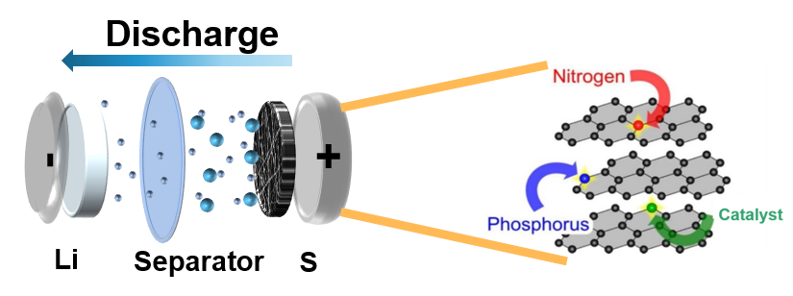
Figura 1. Mechanism of lithium polysulfide adsorption catalytic in Lithium-sulfur batteries

