Título de la comunicación. Garamond, tamaño 14, negrita

Xingqi Chang
¹Universitat de Barcelona / ²IREC
xchan@irec.cat
Mentor: Elvira Gómez. Universitat de Barcelona, Martí i Franquès 1, Barcelona, Spain.
Director: Paulina R. Martínez-Alanis and Andreu Cabot. Catalonia Institute for Energy Research (IREC), Sant Adrià de Besòs, 08930 Barcelona, Spain.

Abstract
As we known, the energy storage in electrochemical energy storage (EES) device occurs through applying an applied voltage, and the potential range and the type of active materials of anode and cathode directly determine the electrochemical reaction mechanism during charge and discharge process. Taking carbonaceous electrodes for examples, various isomers of carbon materials show different charge storage mechanisms at different potential ranges, involving ion-adsorption or/and ion-intercalation. Coupling two carbonaceous electrodes with the same or different ion storage mechanisms can derive into different types of dual-carbon EES devices, mainly including suercapacitors (SCs), metal-ion hybrid capacitors (MIHCs) and dual-ion batteries (DIBs). SC exhibits superior power density while having low energy density. DIBs has high energy density due to their wide operating voltage, but the slow diffusion process leads to the poor rate capability. And as mentioned before, MIHC delivers compromise combination of energy and power density. The difference in energy and power density of the three EES devices is obvious and forms a sharp contrast. Therefore, we naturally make a hypothesis: if these three functional devices are integrated into one device, would the resulting device inherit the respective merits themselves.

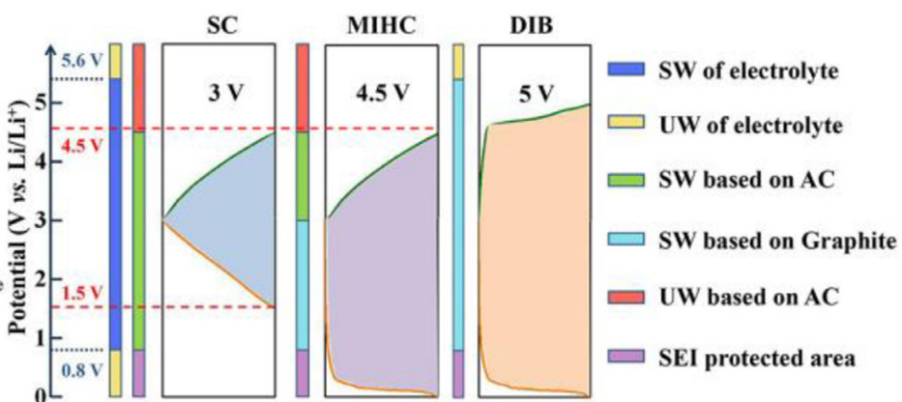
Fig. 1. Schematic of the electrochemical stable windows (SWs) and the electrochemical unstable windows (UWs) of K-ion based on activated carbon (AC) and graphite.

