Study of interfacial effects of CO₂ electroreduction in Pt.

Rufino Cabezas Montero
Instituto de Electroquímica, Universidad de Alicante, Apdo. 99, 03080 Alicante, Spain.
rcm142@alu.ua.es
Mentor: Victor Jose Climent Paya, Universidad de Alicante
Director: Victor Jose Climent Paya, Universidad de Alicante

Abstract
The CO₂ is considered the main responsible of the global warming The CO₂ electroreduction reaction (CO2RR) to fuels and feedstocks represents a viable alternative to help to close the anthropogenic carbon cycle and store renewable energy. The main problem hindering the commercialization of such technology is the electrode needed for the reaction to take place. The overpotential needed on most of the metal electrodes is very high, leading to inefficient energy consumption, and the reaction takes place at a potential range that overlaps with the hydrogen evolution reaction (HER) lowering the selectivity and the efficiency.
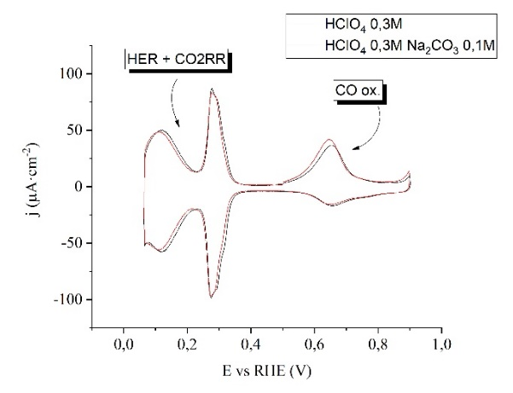
However, the Pt electrode do not share these problems. The hydrogen adsorption on Pt enhances the reduction of CO₂ to CO at potentials more positive than the HER region. Moreover, the CO2RR has been found to be a sensitive structure reaction by exploring the influence of the Pt surface structure reaction at pH=1¹. However, electrolyte effects on the CO2RR on Pt have been never explored. Electrolytes also play an important chemical role in the CO2RR and influence of the electrolyte in the activity towards the reaction is shown for other metal electrodes². Thus, understanding mechanistically the electrolyte effect, by the introduction of different cations on changing the pH of the solution, would help improving the activity and selectivity of CO2RR via efficient electrolyte design. Additionally, the study of the activation energy for the adsorption of (bi)carbonate and its dependence with the Pt surface structure is a fundamental parameter to understand the CO2RR on Pt⁴. Thus, bearing all that in mind, this thesis project addresses both the influence of the electrolyte (pH and cations influence) and the study of the activation energy for the CO2RR on Pt well-defined single crystals by using techniques such as cyclic voltammetry, impedance spectroscopy and differential electrochemical mass spectrometry (DEMS).
Figure 1. Voltammograms of Pt (211) in CO₂ saturated 0.3M HClO₄ with and without Na⁺ while holding the potential 60s at 0.1V. Scanning rate: 0.05 mV s⁻¹.
References
1. Hoshi, N., Suzuki, T. & Hori, Y.. Electrochim. Acta 41, 1647–1653 (1996).
2. Singh, M. R., Kwon, Y., Lum, Y., Ager, J. W. & Bell, A. T. J. Am. Chem. Soc. 138, 13006–13012 (2016).
3. Martínez-Hincapié, R., Berná, A., Rodes, A., Climent, V. & Feliu, J. M. J. Phys. Chem. C 120, 16191–16199 (2016).
4. Botello, L. E., Feliu, J. M. & Climent, V. ACS Appl. Mater. Interfaces 12, 42911–42917 (2020).

