Composite electrodes conductive polymer-Pt (nanoparticles) for monitoring the H₂O₂ in the presence of antioxidants

M.P.Rivas Romeroª,*

ªDepartamento de Química Física y Termodinámica Aplicada. IUIQFN, CEIA3. Universidad de Córdoba (Spain) *e-mail: q62rirom@uco.es,

ABSTRACT
Mercury electrodes have been used to determine the antioxidant activity of food components and natural extracts by monitoring the oxidation of hydrogen peroxide in its presence.^{1,2} The disadvantage of this methodology is the use of the hazardous material mercury. Thus, it is important to use non-pollutant, stable and reliable electrodes for this task. Glassy carbon electrodes, GCE, were modified with poly-neutral red, PNR, and electrodeposited platinum nanoparticles, this giving a stable and reproducible sensor.³
Antioxidants decrease the signal of hydrogen peroxide reduction on the GC/PNR/Pt electrode (Fig. 1). This decrease was used to determine the scavenging ability (the antioxidant activity) of a series of food additives. The scavenging capacity is measured from the volume of 0.1 M antioxidant solution needed to decrease in a 25% the original DPV signal of the hydrogen peroxide reduction (Fig. 2)
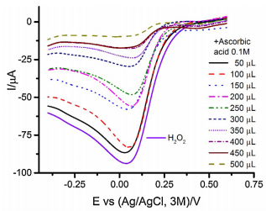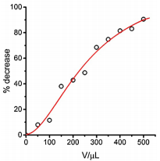
Figure 1 Figure 2
ADVISERS/MENTORS
J.M. Rodríguez Melladoª. ORCID: 0000-0002-7639-5040
REFERENCES
¹Novaković, M. M.; Stevanović, S. M.; Gorjanović, S. Ž.; Jovanovic, P. M.; Tešević, V. V.; Janković, M. A.; Sužnjević, D. Ž., J. Food Sci., 76, C663, 2011
²Palma, A.; Ruiz Montoya, M.; Arteaga, J.F.; Rodríguez Mellado, J.M., J. Agric. Food. Chem., 62, 582, 2014
³Rivas, P.; Rodríguez Mellado, J.M., Electrochim. Acta., 171, 150-155, 2015
Keywords: Antioxidant activity, Pt nanoparticles, poly-neutral red, modified electrodes.

